Central Massachusetts Regional Workforce Blueprint
2023-2027

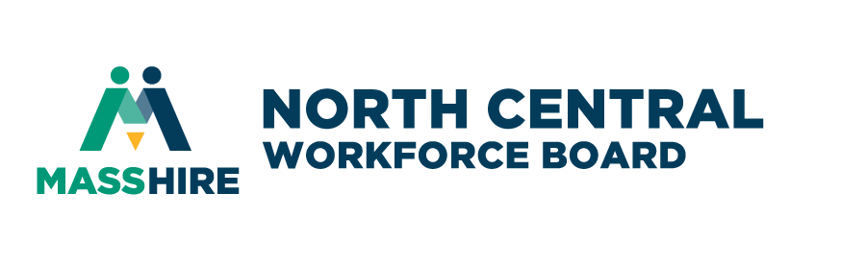
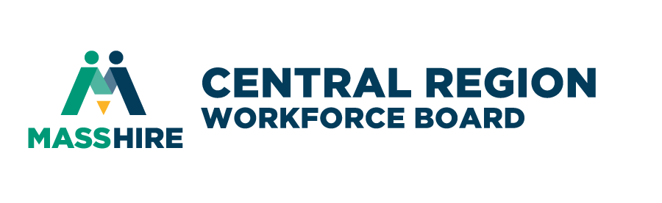

Introduction
The federal Workforce Innovation and Opportunity Act (WIOA) was signed into law on July 22, 2014, and is the first legislative reform of the public workforce system in fifteen years. WIOA supersedes the Workforce Investment Act of 1998 and retains and amends the Adult Education and Family Literacy Act, the Wagner-Peyser Act, and the Rehabilitation Act of 1973, and establishes the publicly-funded national network of Federal, State, regional, and local agencies and organizations that provide a range of employment, education, training, and related services and supports to help all jobseekers secure good jobs while providing businesses with the skilled workers they need to compete in the global economy.

Among other requirements, WIOA calls for local regions to develop strategies and shared service models among the federally funded partners, including;
- The Adult Program (Title I of WIOA), as part of the Department of Career Services (DCS), Executive Office of Labor and Workforce Development (EOLWD);
- The Dislocated Worker Program (Title I), as part of the Department of Career Services (DCS), EOLWD.
- Trade Adjustment Assistance for Workers Programs (Activities authorized under chapter 2 of Title II of the Trade Act of 1974 (19 U.S.C. 2271 et seq.)), as part of DCS, EOLWD.
- Jobs for Veterans State Grants Program (Programs authorized under 38, U.S.C. 4100 et. seq.) as part of DCS, EOLWD.
- The Wagner-Peyser Act Program (Wagner-Peyser Act, as amended by Title III), as part of DCS, EOLWD.
- The Youth Program (Title I), as part of the Department of Career Services (DCS), EOLWD.
- The Adult Education and Family Literacy Act Program (Title II), as part of Adult and Community Learning Services (ACLS), Department of Elementary and Secondary Education (DESE) Executive Office of Education (EOE).
- The Vocational Rehabilitation Program (Title I of the Rehabilitation Act of 1973, as amended by Title IV), as part of the Massachusetts Rehabilitation Commission (MRC) and Massachusetts Commission for the Blind (MCB), Executive Office of Health and Human Services (EOHHS).
- Federal—state unemployment compensation program, as part of the Department of Unemployment Assistance (DUA), EOLWD.
- Temporary Assistance for Needy Families Program (42 U.S.C. 601 et seq.) as part of Department of Transitional Assistance (DTA), EOHHS.
- Employment and Training Programs under the Supplemental Nutrition Assistance Program, (Programs authorized under section 6(d)(4) of the Food and Nutrition Act of 2008 (7 U.S.C.2015(d)(4))), as part of DTA, EOHHS and
- Senior Community Service Employment Program (Programs authorized under title V of the Older Americans Act of 1965 (42 U.S.C. 3056 et seq.)), as part of the Executive Office of Elder Affairs (EOEA).
To accomplish this, local Workforce Development Boards have convened their local partner representatives to establish a Memorandum of Understanding (MOU) detailing service referrals and delivery, data sharing procedures, Career Center operations, and career pathway supports.
As part of WIOA, the Governor of each State is required to submit a Unified or Combined State Plan to the U.S. Secretary of Labor that outlines a four-year workforce development strategy for the State’s workforce development system. As detailed in the Commonwealth’s WIOA State Plan, the Baker Administration has launched several initiatives to better coordinate the broadly defined workforce system with the needs of business as well as focus on expanding the impact on job outcomes for individuals with barriers to employment. One of these initiatives is the Workforce Skills Cabinet, which was created to align the resources of the Executive Office of Labor and Workforce Development, the Executive Office of Education and the Executive Office of Housing and Development – the State agencies that administer the major federal and state programs for job seekers and employers.

Through the Workforce Skills Cabinet, the Commonwealth has established a regional planning process to align the priorities of each region for the agencies within the Workforce Skills Cabinet’s three secretariats. In this way, the Commonwealth is utilizing the required WIOA Regional Planning process to create this new, integrated regional planning process across the economic, education and workforce Secretariats.

On a regional basis, this process seeks to scale up regional workforce development models that provide workers with the skills employers demand. The process is designed to ensure that regional employers, educators, and workforce training officials are coordinated in a way that creates strong talent pipelines for in-demand jobs.

The purpose of the regional planning under the Workforce Skills Cabinet and WIOA is to use the same regional boundaries between economic development, workforce, education, and key partners. Each region has therefore been asked to identify business demand for skills, create regional strategies, and align existing resources to this process. The goal is to ensure that regional employers, educators, and workforce training officials are coordinated in a way that creates strong talent pipelines, for both middle-skilled and highly skilled jobs. The regional planning will support the development of cross-secretariat partnerships formed to support sector initiatives/career pathway initiatives that includes education and training, credential attainment, work-based learning (OJTs or apprenticeships), etc.

Local Workforce Development Boards (working as multi-region partners) have been tasked with convening regional leaders in partnership with education and economic development partners to coordinate strategic workforce priorities, activities, and performance metrics (see attachment 1: Regional Planning Context Diagram).

The Workforce Skills Cabinet combined the Commonwealth’s 16 workforce development regions into seven Workforce Skills Cabinet Planning regions:

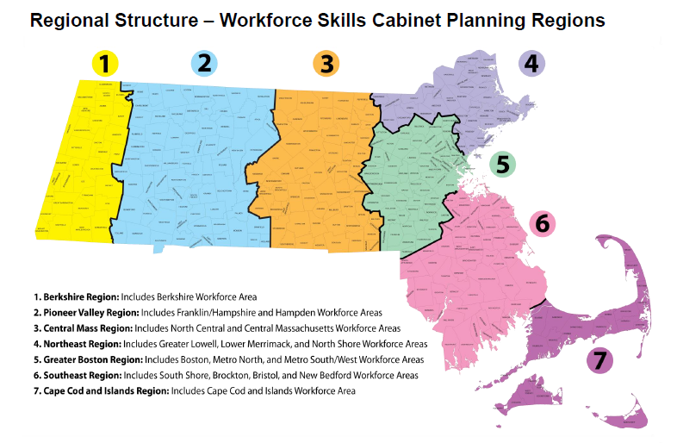
Specifically, the goals of each region are to:
• Identify the growing industries and occupations to be prioritized by system partners that will assist in the economic growth of the region.
• Develop a joint set of action steps to address skills gaps within these industries/occupations.
• Align and drive programming and service delivery across the three secretariats to meet the needs of the priority industries/occupations.
• Help more residents gain the credentials, education and job skills needed for successful careers within high-demand career pipelines.

The following individuals were invited to be a part of the regional planning process:

Individual Name | Individual Title | Organization Name
Joshua Froimson | Manager, Business Excellence | AbbVie
Kerrie Salwa | Executive Director | Central MA Regional Planning Commission
Deb Murphy | Program Manager | Central MA Workforce Investment Board
Jeffrey Turgeon | Executive Director | Central MA Workforce Board
Jeannie Hebert | President and CEO | Central Regional EDA Partnership
Mary Jo Bohart | Director, Economic Development | City of Fitchburg
Jessica DeRoy | Economic Development Coordinator | City of Gardner
Amanda Curtis | Economic Development Coordinator | City of Leominster
Sue Mailman | President | Coughlin Electrical Contractors
Jenna Tait | Contract Manager, Employment Services Program | Department of Transitional Assistance-Fitchburg
Joyce Clemence | Director, Southbridge Office | Department of Transitional Assistance-Worcester
Jason Fitz | Director | Worcester County Sheriff’s Department
Kevin Kuros | Senior Director, Business Development | Mass. Office of Business Development
Glenn Eaton | Executive Director | Montachusett Regional Planning Commission
Arianna Drummy | Director | Worcester Jobs Fund
Adam Duggan | Vice President, Lifelong Learning and Workforce Development | Mount Wachusett Community College
Trish Woodliff | Director of Adult Learning | Montachusett Regional Technical School
Kevin Gaugush | Chief People Officer | Advantage Truck Group
Roy Nascimento | President and CEO | North Central MA Chamber of Commerce
Penny Doolittle | Market Maker | Central MA Workforce Board
Jeff Roberge | Executive Director | North Central MA Workforce Board
Paul Morano | Assistant Chief Development Officer – Business and Community Development | City of Worcester, Executive Office of Economic Development
Kathy Manning | VP of Adult Learning | Quinsigamond Community College
Robin Hooper | Community Life Senior Manager | The Community Builders, Inc.
Janice Ryan-Weekes | Director | Worcester Career Center
Staci Johnson | Director | North Central Career Center
Kelly Aiken | Director | UMass Memorial Medical School
Karen Pelletier | Director of Higher Ed-Business Partnership | Worcester Regional Chamber of Commerce
Christine Cordio | Director | Clinton ABE
Paul Gilbody | CEO | Milford Federal Credit Union
Rebecca Marois | President | Greater Gardner Chamber of Commerce
John Person | Area Director | Massachusetts Rehabilitation Commission

Description of the Regional Planning process:

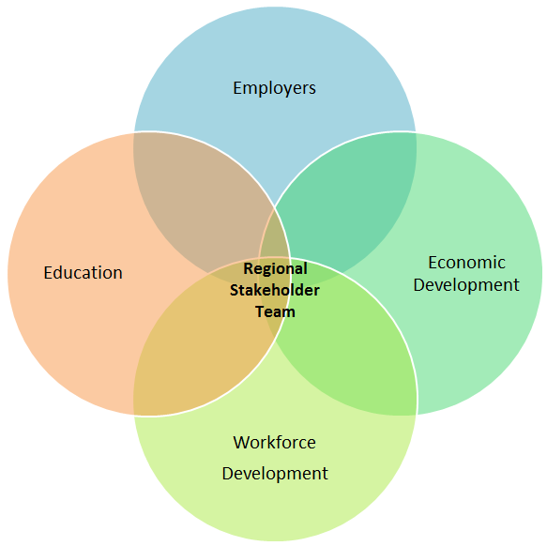
As noted previously, the Central MA region consists of the Central MA and North Central MA Workforce Development Areas. The two local workforce development boards, the MassHire Central MA Workforce Board (MCMWB) and the MassHire North Central MA Workforce Board (MNCWB), have fully embraced the concept of collaborative regional workforce planning and have assembled a strong and diverse team of stakeholder representatives from private industry, education, workforce development, and economic development. The region has conducted planning sessions since the start of the planning process and during these sessions the stakeholders have reviewed regional population demographics, labor market information, and the additional data necessary to confirm industry priorities and supply gaps in our region, Including the results of a survey conducted specifically for distribution to the Worcester Business Journal circulation audience. This survey was sent to the entire Worcester Business Journal audience of key decision makers and top executives in the region The data was collected during the months of November and December of 2023.

Approximately 350 business leaders responded to the survey, yielding detailed information regarding their priorities, challenges, and needs. Brad Kane, the editor of the Worcester Business Journal categorized the results as mostly positive (see chart A) about our Central Massachusetts economy with several key data points that relate to our strategic blueprint overarching assertions.

According to Brad Kane, “Workforce issues remain top of mind, as 65% expect to hire ADDITIONAL STAFF next year (see chart A), but 51% are concerned they will not be able to find the right people with the right skills for the job (see Chart B). More than a fifth of the survey takers said the biggest impediment to business growth is a lack of available workforce (22%).
(see chart C).

For the last few years Central Massachusetts companies have given greater attention to their Diversity, Equity, and Inclusion initiatives. (see chart E).
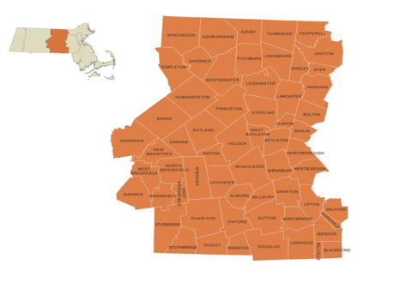
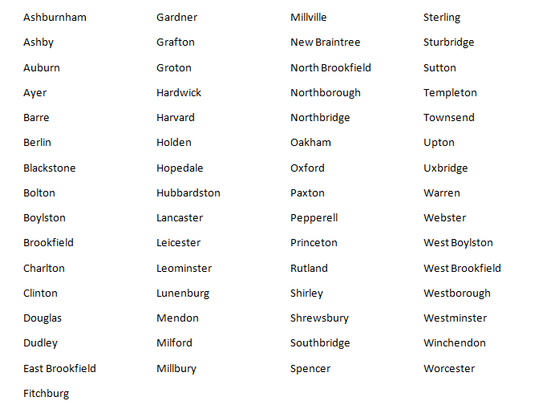
Description of the current state of our region:
From: Labor Market Trends in the Central Mass Region 2012 ww.bostonfed.org/neppc

The Central MA region consists of 61 communities, anchored by New England’s second largest city, Worcester, as well the twin cities of Fitchburg and Leominster. The region borders three other regional labor markets: Pioneer Valley, Northeast, and Metro South/West. The total population of the two regions is 980,161 with a labor force of 437,249. The region boasts of natural attractions such as Mount Wachusett, Lake Quinsigamond, and Purgatory Chasm, as well as historic sites dating back to the local Native American tribes and prominent locations from the French and Indian War, the American Revolution, and later, the Industrial Revolution.
Our region also features prominently as a bellwether for the US economy, being built upon agriculture at the start of our nation and then moving during
the industrial age to become a major force in development of machine-powered manufacturing through the start of the 20th century centered around the abundant water power of our rivers and streams. This rise in manufacturing, however, has given way to other industries over the past fifty years. Healthcare, retail, and human services have grown to take a larger role as manufacturing, especially traditional manufacturing, has faded. In the recent past, state, and local officials have made a concerted effort to invest in the life-sciences industry and have had success in attracting biotech/biomedical companies to the region and supporting the growth of new life-science firms.
In terms of employment rates, the Central MA region continues to mirror the state as a whole economically; our region’s unemployment rate hovers around 3.6% -- a low rate by historical standards.
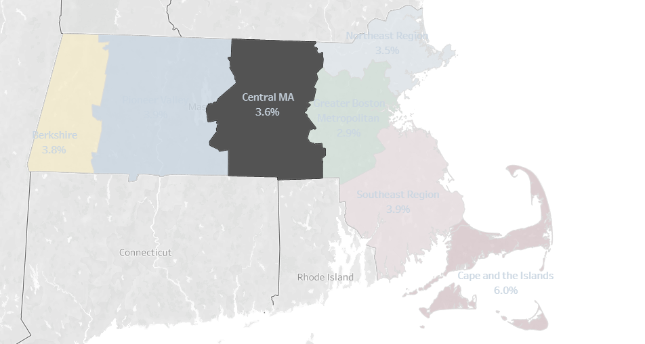
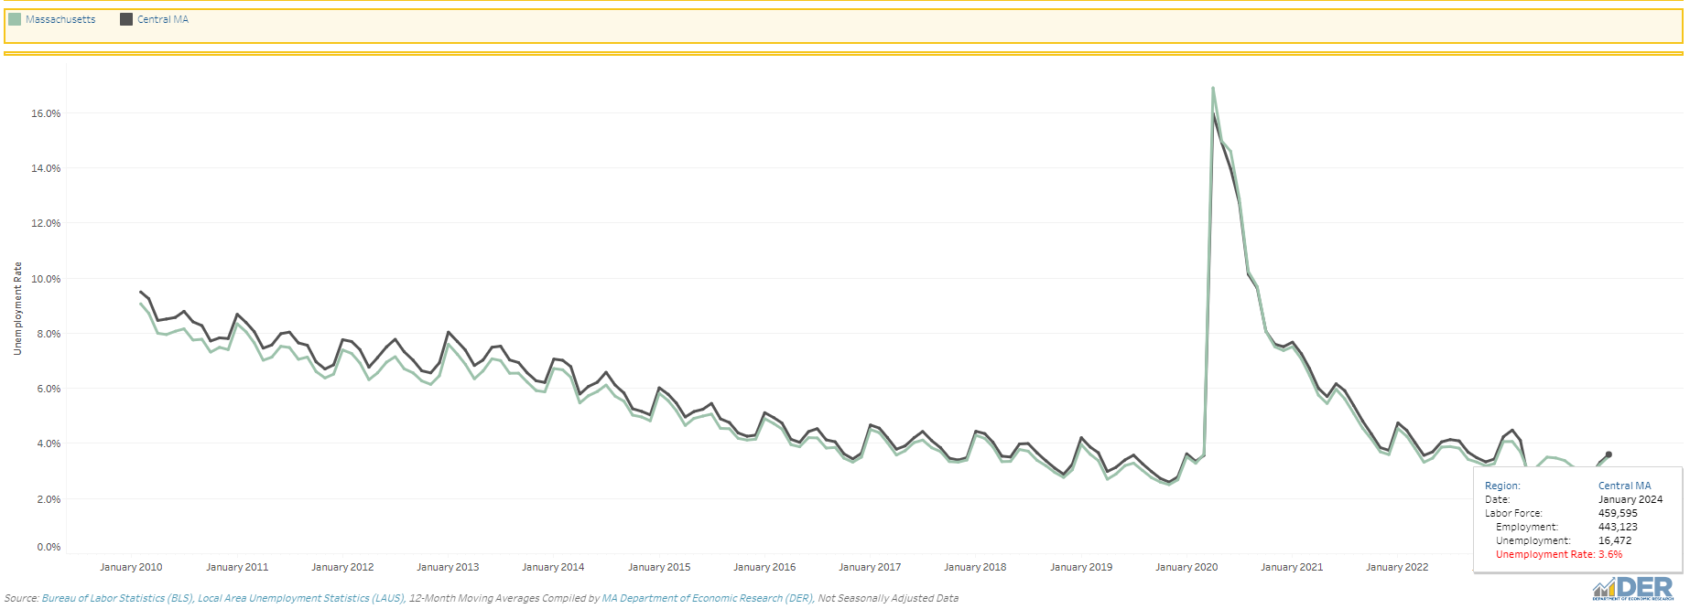
This low rate, however, masks some of the challenges our region’s workforce faces. First, this low rate indicates that many residents in the region actively seeking work are able to find it – making the labor market for these workers more competitive and therefore harder for employers to find candidates without raising wages. But there are additional challenges associated with this data that are less obvious. This includes the fact that the official unemployment rate as announced by the United States Bureau of Labor Statistics (BLS), the “U-3” rate, only includes those who are in the labor force and actively looking for work within the previous four weeks. If a person is unemployed and was looking for work in the last year, but not in the past four weeks, the individual is considered a “discouraged worker” by the BLS, and not counted in the U-3 rate. If you were to broaden the U-3 measure to count these discouraged workers (plus those working part time who wish full-time work) as the BLS does in its U-6 measure, the unemployment rate in Central Massachusetts climbs to 6.0%, double the statewide U-3 rate of 3.0%. Yet even this statistic, as broad as it is, only includes those who have looked for work in the past year. If you were to measure those who have given up looking for work for more than one year, the statistic no doubt climbs much higher still -- but it is difficult to measure since this population, being much harder to define from available data, is not tracked by the BLS and has thus been largely made invisible in official statistics.

Critical trends in regional demographics that impact the workforce:
The planning team has identified two demographic trends in our region that have a significant impact on our workforce as we move forward. The first is our aging population which is already having an impact in several industries, including manufacturing and other “traditional” trades. Many of the older, more experienced workers are retiring and this is leaving gaps that are proving difficult for employers to fill as younger workers are not choosing to enter these fields in numbers sufficient to meet the need. For example, there are a sizable number of maintenance mechanics and machine operator positions that will be available as the current workforce retires in the next 3-5 years. Without new candidates to replace these workers, the shortage will grow critical, jeopardizing the ability of these companies to meet customer demand, let alone growth opportunities they would need to forgo. Similarly, diesel technicians, construction workers, and other skilled trades appear to be of less interest to many youths. Some have argued that youth are counseled from an early age that a college degree offers them a better career path, and thus look to go that route instead of a hands-on profession that is not aligned with the degree-track academic system. Beyond this, it would appear that many youths seek jobs that offer more social rewards, aka, a higher level of esteem, since society seems to devalue income derived from physical labor.
Changing demographics in the population will have far-reaching effects on the labor force, the economy, and employment over the 2016–26 decade. The overall labor force participation rate is projected to decline as older workers leave the labor force, constraining economic growth. The aging baby-boomer segment of the population will drive demand for healthcare services and related occupations.
-- US BLS; Projections overview and highlights, 2016–26
A corollary issue we are seeing with an aging workforce is that many older workers do not appear to be equipped with the appropriate skill set to work in a technology-rich workplace, such as advanced manufacturing. For instance, many older workers/job seekers are not familiar with Computer-Numeric Control (CNC) machining, which is becoming the norm within the manufacturing industry. CNC machining is an automated process and requires knowledge of software and programming. While we have already completed a large amount of CNC training in our region, we will need to do more in order to upskill our aging existing workers and prepare our younger workforce.
A further issue related to our aging population is the need it will bring for increased medical care and other social services as the population moves into the post-retirement stage of life. This demographic shift will significantly impact many of our region’s larger industry sectors, such as healthcare and the level of staff necessary to care for our region’s seniors.
It is well understood that in order to foster strong economic growth in the future, the Central MA region needs to align the education of its labor force to meet the demands of the region’s employers. The higher education institutions in the region can play a key role in influencing the future supply of workers with post-secondary degrees. This supply will be critical to help meet the demographic challenges posed by the aging workforce and the increasing demand for educated workers.
-- Labor Market Trends in Massachusetts Regions: Central Mass;
Boston Federal Reserve

The second critical trend we are seeing is growth of our immigrant and refugee populations. While these new Americans bring the potential to fill many supply gaps in our priority industries, they also often present with more potential barriers to employment. Some of the barriers we are already seeing include a lack of English language proficiency, limited education beyond high school (or credentials that do not transfer here from their previous countries), and a lack of job-specific skills. It has been reported that the waiting list for our region for English for Speakers of Other Languages (ESOL) classes is greater than 1,000 candidates. These people’s lives are on hold as their ability to work in living-wage jobs is significantly impaired by their lack of English fluency.

Past and current high-level industry trends impacting workforce needs:
There are numerous high level industry trends occurring in our region that are impacting workforce needs, such as the rise of technology and automation, changes to business operations and management practices, issues involving the “pay squeeze” for some industries, and employer responses to public policy changes.

Increase in technology and automation
Increasing technology has been a major driving trend in our region, like others throughout the Commonwealth and beyond. Technology has always impacted workforce in a variety of ways and continues to do so today. In the past, modern technology such as the harnessing of electricity provided power to factories and freed them from the need to be near the rivers which drove the machinery. Gas motors forever changed the way we transport goods and materials – and changing the mix of workers needed to build and maintain the new automobiles and trucks, and the roads they ride on. Today, we see the rise of automated manufacturing, self-checkout kiosks in markets and gas stations, and now the growth of the “gig economy” made possible by the use of real-time online platforms. This rise in technology has reduced the need for employees doing lower-level, repetitive functions, and so, teen employment has dropped as a result. The gig-economy allows people the freedom to choose when and how they wish to offer their services, but the work comes with little or no benefits, job security, or growth potential – an Uber driver is unlikely to advance up the company ranks. In Information Technology, project-based gig work may be well paying, but comes with the stress of not knowing what work may be available in the future, and workers are increasingly competing with talent based oversees since production can be shared seamlessly over the world-wide web.
Automation in the manufacturing sector is creating greater efficiencies for manufacturers and yielding ever-higher productivity as companies are able to produce more goods with less workers, leading to layoffs in this industry. Unfortunately for employers, they are in a race with a generational shift as older workers begin to retire in greater numbers, overwhelming their ability to replace these aging workers with machines. And the jobs that remain in advanced manufacturing require ever more comfort with the use of computers to interface with the new machines on the shop floor. Our vocational-technical high schools are already attempting to address this need by adding programs in engineering, advanced manufacturing, and robotics, but not at a high enough scale to prepare the number of workers necessary to replace the existing workforce preparing to retire. Further, a considerable number of the students attending these schools are going off to college after graduation, and not directly entering into the local and regional workforce.
In the transportation industry there has been significant research on the development of autonomous (so called driver-less) vehicles and discussion in the workforce development world regarding the disruption this will have upon employment as drivers. Discussions with local distribution industry professionals indicate that this innovation is many years away from having an impact locally – while the technology may be rapidly advancing, the prohibitive cost of buying and maintaining an autonomous delivery truck will prevent wide scale implementation and any noticeable decline in local jobs driving. More imminent, these professionals suggest, is the greater utilization of automation in the sorting, handling, and preparation of products as they move through the distribution network. Beyond the short term, it is anticipated that delivery trucks, even autonomous ones, will still need a human presence on board for the foreseeable future to ensure the safe handling and delivery of goods and material.

Changes to business operations and management practices
Another high-level industry trend that is affecting workforce development is the changing management structures that businesses utilize, such as the rise of outsourcing for much non-core business administrative and support services like human resources, payroll processing, marketing, custodial/janitorial services, etc. Businesses have also turned to the use of third-party temporary firms to fill short term employment needs or for greater screening for identifying qualified candidates for “permanent” status as a company employee. Businesses have increasingly turned to these alternate organizational models in order to achieve greater efficiency, however, they have also had some unintended consequences, including a lowering of business reputations in the community-labor pool, and a decrease in the ability to promote from within as talented entry level support staff learn about the business and further advance their careers through company-sponsored education and professional development.

Pay-Squeeze
Another trend in our region is the trend whereby employers have been caught in a “pay squeeze” affecting their ability to pay workers more in times of greater employer demand; unfortunately, we are seeing across some of our priority industries such as manufacturing, health care and social assistance that salaries are not increasing at a rate keeping up with the demand (for instance, manufacturing saw a 2.95% increase in total wages over the past 10 year period and health care an increase of 4.99% total wages, both below the regional average for all industries of 7.82% and far lower than the increased hiring demand would anticipate). One likely reason for this is that while the Commonwealth has increased minimum wage over the past three years, the ability of the employers to pay their workers a higher wage relative to the minimum wage is being capped by the funding available on the revenue side. In health care, this is a result of a public reimbursement system that caps the rate of funding and therefore leaves the revenue side flat while employers in other industries around them (including fast food and retail) have increased their pay due to the minimum wage mandate. This is also occurring in child development centers where staff pay rates are highly dependent on the public voucher supports available to the Centers for the moderate and low-income families they serve. Without a rise in the voucher rates, paying staff more is a difficult proposition. Similarly, local manufacturers have faced pressure from their customers to meet the prices of their competitors, many of which are in countries with much lower pay rates, such as China. This pay-cap issue therefore alters the natural labor-market and the increase in pay expected in order to entice more people to seek employment in that field – especially if the work requires an investment in a potential candidate’s time and money for training in order to be qualified for the job(s) available. This, in and of itself, has large implications for the public workforce system, as it suggests increased training alone may not be sufficient to meet the demand.
Pay Cap – Candidate Pool Model

Employer Responses to Public Policy
As noted previously, the Commonwealth’s increase in the minimum wage has fostered changes in the labor-market at the lower end of the pay scale. Employers in numerous sectors that pay at or slightly above minimum wage have had to adjust their budgets to accommodate the rise in hourly staff pay. For some, this has not appeared to have been a major burden as slight increases in product prices have offset the additional labor costs.
Another operational trend we have identified is that costs to employers for health insurance continue to climb and this trend is not anticipated to change any time soon. At the Federal level, the Affordable Care Act (ACA) appears to be slowly being dismantled and the actual coverage for services is declining. Our smallest employers often cannot afford to offer health insurance to their employees. Massachusetts law allows employers of fewer than 50 full-time equivalent positions to choose whether or not to offer health insurance. Since our region has many small companies – in fact, the average number of employees per company is just below 38 -- workers in our region often have to purchase health insurance through the Massachusetts Health Connector at their own cost. The rising cost of health care puts upward pressure on insurance premiums. In response, employers and health plans try to limit premium increases using strategies such as offering more high-deductible plans and increasing co-payments, co-insurance, and out-of-pocket maximums. These approaches represent a cost shift from insurers and employers to workers and further complicate the labor market as workers fear the loss of employer-sponsored health insurance and employers must decide how to meet the rising costs.

Critical trends in occupational employment history in the region:

Shifting of the region’s Industry/Occupational Mix
As noted previously, the industrial base of the Central MA region has shifted the past several decades from a manufacturing focused economy to one that is more balanced between industry sectors, including healthcare, education, professional services, and retail. While this shift has meant less dependency upon a single industry sector, it has also meant the loss of many family-supporting wage jobs for those with limited formal education.
There continues to be a rising need for health care workers at most levels of clinical services and at a variety of health care providers, including community health centers and patient triage clinics, long term care facilities, and hospitals. According to the MA Department of Economic Research, the projected employment in Health Care and Social Assistance from 2020 to 2030 in our combined Central MA region will rise by nearly 10,000 positions – from 69,997 employees to 79,584. Similarly, retail employment is expected to grow by 3,049 from 35619 to 38,668 across the region. During this same timeframe, educational services (including teachers and teacher assistants) are anticipated to grow by 3,548 employees.
One sector we are seeing a significant rise in is the life sciences sector (an anticipated gain of more than 1,700 employees). Fortunately, with four public institutions of higher education in our region offering training/education to prepare people for careers at various levels of this growing sector, we are well positioned to take advantage of this opportunity.

Top three challenges facing the region’s businesses and industry over the next four years:
A survey of Worcester Business Journal audience results of local businesses helped identify the top challenges facing employers regionally. Overwhelmingly, employers identified finding and retaining talent as one of their top three challenges, with high operating costs and lack of affordable housing (see chart C). Overwhelmingly the survey reiterates the “very” concerned response as the highest percentage among respondents who could also reply “mildly” concerned or “not at all” concerned when it comes to employer’s confidence. Matching with the right people with the right skills when there is a job opening is top of mind (see chart D). Our regional blueprint survey data and research supports within the challenge of finding and retaining talent, the most significant factors involved included the aging of our workforce, lack of work-readiness/social-emotional skills, and barriers to employment such as English language competency, unreliable transportation, criminal background concerns, and substance abuse.

Top 3 regional workforce priority industries:
Based upon the State criteria and regional criteria set by the planning team (see section III below) the following industries were deemed priority industries for the region:
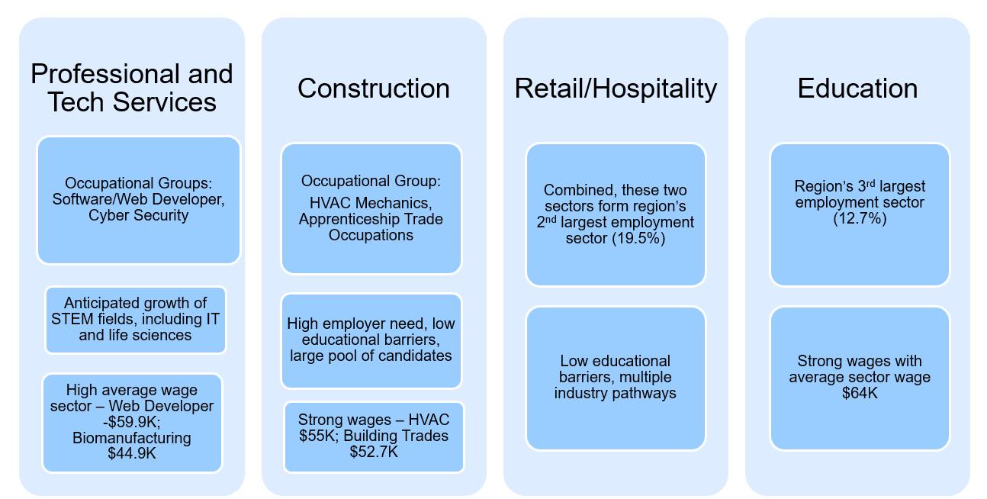
Additionally, the following industries were identified as critical industries for our region:
Healthcare
- CNA/PCA (inc. EKG and phlebotomy)
- LPN – RN
- Pharm. Tech
- Med Asst
- Direct care workers
- Medication technician
- CHW/patient navigator…..will be billable starting Jan. 1st (peer mentors/coaches role for behavioral health)
- Clinical behavioral health staff – licensed mental health counselor
- Technologists – surgical techs; Rad tech, resp tech, Xray tech,
- Medical interpreters
Transportation/Logistics/ Warehousing
CDL Drivers
Diesel Technicians
New:
Facilities Maintenance mechanics
Manufacturing
CNC Machinists
Quality Control Techs
Production Workers
New:
Robotic - Machine Techs
Photonics
Biotechnology (formerly within professional services)

Industries currently facing the most significant workforce development challenges:
The planning team has identified Healthcare & Social Assistance, Manufacturing, and Transportation, Warehousing, and Logistics as facing the most significant workforce development challenges, followed by the critical industries identified above, Professional and Technical Services, Construction, Retail/Hospitality, and Education.

The top occupations or occupational groups in which the region is facing the most significant employee shortages:
The top occupational groups in which the region is facing the most significant employee shortages are:
Occupational Group 1: Health Occupations
- Certified Nursing Assistant, LPN, RN, Pharmacy Tech, Direct Care Worker, Direct care workers
- Medication technician, Community Health Worker/patient navigator, medical interpreters, clinical behavioral health staff – licensed mental health counselors, and Technologists – including surgical technicians; radiology technicians, respiratory technicians, and X-ray technicians.
Occupational Group 2: Manufacturing Occupations
- CNC Machinist, Quality Control Technician, Production Worker, life-science production
- High employer need (960+ short term openings) and engagement, good average wages - especially with experience ($46,588 sector average), fairly low educational barrier
- The number of machinists is anticipated to grow by 7.76% in the Central MA Workforce Development Area and 9.13% in the North Central WDA by 2027, fueled by the anticipated need to replace existing workers due to retire.

Occupation Group 3: Transportation, Warehousing and Logistics Occupations
- Commercial Drivers; Diesel Technicians; Industrial Maintenance Mechanics
- High employer need and engagement, good wages ($34,300 average for Class-B; $53,200 for Diesel Tech), low educational barrier, strong pool of candidates

Occupational Group 4: Construction Occupations
- HVAC Mechanics, Apprenticeship Trade Occupations
- High employer need, strong wages (HVAC - $60,574; Building Trades - $54,893), low educational barrier, large pool of candidates.
- Apprenticeship trade occupations offer employees a nationally recognized credential supported through paid hands-on work and related training instruction (RTI)

Occupational Group 5: Professional, Scientific, and Technical Services Occupations
• Software/Web Developer, Cyber Security
› High anticipated growth, strong wages (Web Developers earn a median annual salary of $77,294 according to job postings for the Worcester Metropolitan Statistical Area on Lightcast Labor Insights; Bio-manufacturing technicians earn an average annual wage of $56,491 according to the US Bureau of Labor Statistics)The supply to demand ratio indicates a large gap in web developers as there are only .12 qualified candidates for each opening in this field
› Life sciences employment anticipated to grow by 14% by 2027 in the Central MA WDA

Occupations offering a “career pathway” for workers to move to higher skills and wages, especially workers starting at entry-level:
We are fortunate in our region that we have several occupations that offer a career pathway for workers that are supported by a strong network of career development and educational institutions. It is our goal to strengthen articulation agreements between regional partners to ensure students seeking to enter or advance in their careers will have access to education and training linked together to scaffold their success. As a regional strategy we are also supporting the development of a strong apprenticeship system to allow workers to advance their careers through paid hands-on work and formal education. Apprenticeships and associated pre-apprentice training has been established in the building trades, manufacturing, commercial drivers, diesel technicians, and pharmacy technicians.
We have created regional career pathway charts developed to assist students, parents, guidance counselors, job seekers, and others about the variety of jobs in a given industry and the education/work experience necessary to advance from one level of employment to the next. (See attachment 3: Regional Career Pathway Charts)
The most significant broad labor supply challenges and opportunities facing the region over the next 5 years based on existing regional workforce:
The most significant broad labor challenges facing the region over the next five years are:
- Aging workforce
- Lack of employment readiness & social/emotional skills
- Increase in share of workforce needing English skills.
- Affordable childcare
- Limited transportation

Aging workforce
Based on our recent employer survey, the most significant challenge facing our businesses is finding and retaining talent. Employers report the loss of older workers as they retire is creating larger supply gaps within our priority industries and this is bolstered by the data of our region’s workforce (25.5%) is aged 55 or older. The added challenge is that these workers are often the most experienced so when they retire, it is difficult to replace them with workers with the same level of knowledge and skill set.
Lack of employment readiness & social/emotional skills
Employers also report that they often see job candidates and new hires that do not have the soft skills needed for performance in the workplace. These skills include time management, communication, social-emotional awareness, and teamwork. Complicating this challenge is the fact that these skills are hard to measure and also difficult to teach in a classroom setting.
Increase in share of workforce needing English skills
The regional demographic trends indicate that the region‘s population growth has been fueled by net inflow of New Americans (immigrants, refugees).
Over the past decade, the share of foreign-born residents has grown by 8%, and the percent of residents in the region of Hispanic ethnicity has grown by 14%.
This inflow of New Americans includes a significant portion that have limited English communication skills. Regionally, it is reported that 8% of residents have limited English proficiency. In order to overcome their barriers to employment, this population typically requires remedial services in English Speakers of Other Languages (ESOL) and/or Adult Basic Education (ABE) classes. Depending upon their past work experience, they may also need occupational training prior to being hired. A small percentage of our immigrant/refugee population may arrive highly skilled but non-credentialed here in the U.S. They may also be faced with a language barrier and/or a need for an additional certification or credential before being hired. Unfortunately, the current wait list for enrollment into ESOL classes is more than 1,000 and funding for additional classes is limiited.
Challenges Surrounding Childcare in the Region
Available and affordable childcare continues to be a significant barrier to employment for residents (families?) In the Central region. Following COVID, many childcare facilities closed, the majority in the family childcare sector. This left some families with no choice other than to require a stay-at-home arrangement. For others, the high cost of childcare meant a reduction in income available to pay for housing, food, and other necessities.
Another issue is the wage paid to childcare workers. This industry does not generally pay a living wage until a childcare worker reaches the higher levels such as lead teacher or Center Director.
Limited Transportation
The Central MA area contains a few cities, numerous towns, and also rural communities. This variety affords residents opportunities to experience the rich diversity of these various communities; however, it makes transportation a challenge for those without a dependable vehicle. Public transportation is available throughout much of the region through fixed bus routes from the Montachusett Regional Transit Authority which serves 21 communities in the northern part of our region and the Worcester Regional Transit Authority which serves 35 communities. Connection to the MBTA commuter rail service is offered in Fitchburg, Leominster, and Worcester, and paratransit service is also available throughout most of the region. Unfortunately, given the limited amount of fixed route service outside of Worcester and Fitchburg, utilizing public transportation for employment outside these cities is often not a viable option for job seekers/employees.

The top 3 broad labor supply opportunities facing the region over the next 5 years based on the existing workforce in the region:
The top broad labor supply opportunities facing the region over the next 5 years based on our existing workforce in the region includes integration of New Americans into the workforce, incumbent staff development, and expanding the labor pool to non-traditional workers.
Integration of New Americans into the workforce
As noted previously, the growth of our region’s workforce has been fueled by the influx of people born outside the United States settling in our region. This includes immigrants, refugees, and other foreign-born residents legally able to work in the US.
Incumbent staff development
The second opportunity is increasing the skills of existing staff to meet company demand. This requires employer commitment to employee mentoring, training and development, but may be done more easily than attempting to lure workers from outside the region, especially for entry and middle-level jobs that typically do not pay enough to entice people to uproot their residence and requires additional costs to employers attempting to have a meaningful presence away from the location they’re hiring in.
Some of the ways businesses might develop their employees could include:
- Skills training, either in-house or through outside training centers
- Opportunities for promotion and/or career development
- Coaching and mentoring
- Offering tuition reimbursement
- Encouraging pursuit of continuing education
- Development of a formal Registered Apprenticeship to promote a set career advancement pathway for staff

Employees report feeling valued when they see that the company is investing in them. This growth and development help employees expand their knowledge, skills and abilities and apply the competencies they have gained to new situations. This translates into positive gains for the organization by enhancing organizational effectiveness, improving work quality, and helping business to attract and retain top talent.
Expansion of the traditional labor pool
A third opportunity exists in expanding the existing labor pool through skill preparation, training, and work support for non-traditional workers in various industries. This includes increased hiring of people with a disability in manufacturing, expanded career opportunities for people with criminal backgrounds/ex-prisoners, and older workers seeking a second career.
UI Claimant population and the region’s largest supply of unemployed workers by job type:-
A review of the UI Claimant reports for December 2023 shows that there were 7,541 claimants for the region and the average weekly wage claim was $1092.39. Of these claimants, 5.8% were between ages 20-24, 22.8% were ages 25-34, 23.1% were ages 35-44, 19.3% were ages 45-54, and 19.6% were ages 55-64.
In terms of occupational backgrounds:
- 1,059 had Management backgrounds
- 1,106 had Construction and Extraction backgrounds
- 653 had Office and Administrative Support backgrounds
- 661 had Building and Grounds Maintenance backgrounds
- 406 had Production backgrounds

Characteristics of unemployed and underemployed workers in the region:
The four prominent characteristics of the unemployed and underemployed workers in our region that the regional planning team identified are:
- Older workers & long-tern unemployed
- Lower formal education level
- Lack of English proficiency
- Geographic location/transportation

Many of our older workers continue to struggle with finding full-time employment and a significant portion of them are long-term unemployed. Their biggest challenge is that they come with years of experience and often at a fairly high salary. They find themselves trapped by employer stereotypes such as not sticking around long (flight risk) and costing too much in terms of salary, health insurance and retirement. Businesses often do not want to take a chance on these older workers. Another issue facing the long-term unemployed workers is discrimination based on the duration of their unemployment. They are often faced with an uphill battle when competing for employment with currently working younger job applicants. We need to work with our business partners to more clearly understand that hiring should be based on one’s ability to do the job, not his or her age or current employment status.

Education level is another characteristic of our unemployed and underemployed workers. Some workers only have a high school diploma or high school equivalency credential when employers require a college degree. Many are raising families and do not have the resources and/or time to step away from the work world and return to school. Working with our education partners, we need to continue to find alternative ways to help these workers get the education or training they need. Possibilities include tuition reimbursement from the employer, evening or weekend classes, and online education.

As noted previously, there exists an extremely high need in our region for ESOL classes. One of the biggest barriers to employment right now is the lack of English proficiency in our job seekers combined with the fact that our local, publicly funded ESOL programs have extensive waiting lists. One way for us to address this issue is to educate our business partners and encourage them to apply for a Workforce Training grant to provide ESOL training for their workers.

Description of the region’s existing pipelines of new workers (credentials) across public and private secondary and post-secondary institutions:
There are a large number of educational institutions and training entities in Central MA and an extensive amount of career-related education and training that is already taking place or anticipated to begin over the course of the next four years. Educational institutions in the Central MA region include three public universities (the University of Massachusetts Medical School in Worcester, Fitchburg State University, and Worcester State University), two community colleges (Quinsigamund Community College and Mount Wachusett Community College), several private four-year colleges (Nichols, Holy Cross, Assumption, Anna Maria, Cummings School of Veterinary Medicine at Tufts University, Massachusetts College of Pharmacy, Becker, Clark, and Worcester Polytechnic Institute), as well the Grafton and Shriver Job Corps Centers, and five vocational schools, which offer both day and evening programs; Montachusett Regional Vocational Technical High School, Worcester Technical High School, Bay Path Regional Vocational High School, Blackstone Valley Vocational High School, and the Leominster High School Center For Technical Education Innovation (additionally, the Assabet Valley Vocational High School is located on the edge of our region, providing programming to day and evening students residing in our region). There are numerous Career Technical Education (CTE) providers including the Worcester Community Action Council, the Fieldstone School, Youth Opportunities Upheld (YOU), Inc., the Blackstone Valley Hub for Workforce Development, Training Resources of America, the South Middlesex Opportunity Council, Worcester Public Schools Night Life and Adult Basic Education Center. Additionally, Career Technical Initiative providers including, Montachusett Regional High School, Minuteman Vocational Tech, and Nashoba Valley Technical High School.
These regional education and training partners, and others not mentioned by name above, are doing much to align their efforts with the demands of our region’s employers. Some of these efforts include:
- Worcester State University (WSU) is leading a multi-year effort to encourage interest among high school students in careers in K-12 education, with a particular focus on encouraging students of color to consider this career path. It is grounded in their Education Department and led by WSU’s Associate Dean of Education, Dr. Raynold Lewis, with special emphasis on identifying potential students from the Worcester Public Schools.

- WSU also has a long history in the area of teaching English to non-native speakers, and currently boast of three outlets in that regard: through the Latino Education Institute, WSU offers English language training and assistance to both students in the local school system and their parents; through their Intensive English Language Institute (and the WSU Graduate & Continuing Education division) that offers a collegiate-focused preparation program suitable for students and professionals; and a graduate level program for teachers of ESL.

- The Worcester Public Schools (WPS) 2023-2028 Strategic Plan and newly released Vision of a Learner demonstrate the district’s commitment to helping all WPS students to become future-ready in order to lead meaningful and purposeful lives after high school. WPS scholars will leverage a broad set of multi-literate skills to graduate as problem solvers, curious learners, empowered individuals, effective communicators, and engaged community members.

- WPS also remains committed to numerous efforts to expand access to high-quality CTE programs including but not limited to:
- Worcester Technical High School (WTHS) continues pushing the enrollment limit of 1,500 students. WTHS has 23 vocational-technical programs. The building and its 23 programs are the cohesive infrastructure supporting many community programs, Innovation Career Pathways, and Nightlife programs.
- WPS is also expanding program offerings at their academic high schools. North High School is offering Business Technology along with its existing Allied Health program. They also offer a non- Chapter 74 Early Childhood Education program. Doherty is continuing its Engineering program and is adding 3 new Chapter 74 programs in the fall. Those programs are Programming and Web Development, Construction/Craft Laborer and Marketing, Management and Finance. Doherty will also be exploring a Biomedical program at the new High School over the next few years. South High will continue its Diesel Technology, Culinary, and Early Childhood programs. They also offer a non-Chapter 74 Automotive program.
- Innovative Career Pathways (ICP) – WPS has the largest ICP program in the state supporting 300 WPS annually to access high-demand industries across seven career pathways: Advance Manufacturing, Allied Health, Biotechnology, Business & Marketing, Computer Science, Construction & Related Engineering, and Information Technology. ICP students learn industry relevant knowledge and skills in two pathway specific technical courses offered as part of an extended day program at WTHS. Students receive extensive career exploration and development support and have opportunities to take dual enrollment courses, earn industry recognized credentials, and participate in multiple paid internships. Industry partnerships and networking opportunities are embedded throughout all ICP pathways.
- WPS, in partnership with QCC, is offering an evening certificate HVAC program for 15 students at WTHS. This program is currently a certificate program that QCC is looking to move to an Associate degree program in the near future, with possible Pell eligibility.
- WPS has expanded its Night Life (evening CTE program) to offer area residents access to additional in-demand, affordable, short-term CTE programs such as Clinical Medical Asst Training, Diesel Technician Training, Pharmacy Technician Training, Electrical Code & Theory Classes, Plumbing Code & Theory Classes, and Intro to Welding.
QCC is deeply committed to aligning our programming to effectively meet the evolving needs of local employers and the broader workforce. The key initiatives include:
- Equipping Non-English Speakers for Employment: QCC develops and delivers programs tailored to non-English-speaking individuals and those with limited English proficiency. These programs encompass:
  - Integrated Basic Education and Training (IBEST) programs in crucial fields such as healthcare, accounting, early education and care, biotechnology, and advanced manufacturing.
  - Career training programs offered in Spanish within healthcare and business domains.
  - Dual-language programs specifically crafted for Early Education and Care.
- Empowering through Apprenticeships: QCC boasts a robust apprenticeship program that seamlessly blends classroom instruction with on-the-job training, priming individuals for successful careers. These apprenticeships and pre-apprenticeships span priority sectors including healthcare, hospitality, biotechnology, and IT. We are actively exploring avenues to expand this program to include the awarding of apprenticeship degrees, underscoring our commitment to growth in this area.
- Fostering Competency-Based Education: QCC is actively developing competency-based education programs with the aim of streamlining career preparation and facilitating a quicker entry into the workforce.
- Supporting Adult Learners through Mass Reconnect: Through the Mass Reconnect program, QCC is dedicated to supporting adults without college credentials to enroll in certificate or degree programs, equipping them with the skills needed to fill regional job vacancies.
- Industry Partnership Initiatives: Through the Center for Workforce Development and Continuing Education, QCC collaborates closely with employers to leverage state grants aimed at addressing workforce needs in priority industries. Programs such as the Donnelley Success grants, SCALE grants, and the Returning Citizens grants are specifically tailored to prepare workers with the requisite credentials for meaningful employment opportunities.
- Fast-Track Skill Development: Through the Center for Workforce Development and Continuing Education, QCC offers Fast-Track skill development programs designed to expedite the journey from skills training to employment. These programs feature streamlined timelines without compromising on quality, ensuring rapid entry into the workforce. Additionally, we provide a comprehensive suite of programs tailored for career advancement and career transition, allowing individuals to pursue their professional goals and provide employers with the skilled workers needed.
- Basic Skills for Adult Learners – Through QCC’s Adult Community Learning Center, QCC delivers programming for English language learners and adults seeking a high school equivalency, such as a GED. These programs prepare adult learners to move directly into the workforce or into additional training and education.

Quinsigamund Community College offers a diverse range of healthcare certificate & degree programs that are designed to meet the evolving needs of the regional workforce in healthcare. Programs in allied health, emergency services and nursing ensure we have a pipeline of health professionals available for local employers.
Clark University was founded in 1887 as one of the first all-graduate institutions in the country. Today, Clark promotes a rigorous liberal arts curriculum within the context of a research experience that addresses challenges on a global scale. Clark privately funded, coeducational, and nonsectarian, and offers bachelors, masters, certificate, and doctoral degree programs in a wide range of disciplines. Many of these disciplines apply directly to the needs of priority industries and occupations in Central Massachusetts. Responding to these needs, Clark’s Corporate Outreach Programs provide flexible offerings focused on in demand skills development. We understand that one size does not fit all and offer delivery, financial and operational models that fit the unique needs of businesses and their employees.
- Clark’s Micro credential Program delivers rapid cycle training that is online, skills driven and extremely cost effective. Upon completion, students earn digital badges and certificates for in-demand skills like data management and cyber security. Additionally, Clark can offer employers customized credentials based on graduate courses based on an employer’s unique needs. Finally, Clarks Graduate Programs offer advanced degrees and certificates in Business disciplines like Management, Accounting, Finance, Business Analytics and Marketing. Technology degree programs include Computer Science, Information Technology and Cyber Security, Data Analytics and Project Management.

• Rapid Cycle Training
• Clark Curated Micro credentials
• Online, cost effective and skills driven
• Digital badges and certificates
• Customized Credentials
• Graduate level courses packaged for your unique needs
• Customization and new course development as needed
• Graduate Certificates
• Business Analytics, Post MBA, Management Fellows, Non Profit Leadership
• Advanced Degree Programs
• Business
• Marketing, Finance, Accounting, Business Analytics, Management
• Technology
• Data Analytics, Information Technology, Computer Science, Project Mgt
Fitchburg State University offers a number of degree options at both the graduate and undergraduate level geared towards individuals who work full or part-time and need greater flexibility in their schedules. These programs are in areas such as business, nursing, and education, which align with regional workforce needs to prepare or advance students in their careers. Additionally, Fitchburg State offers several on-line undergraduate degree completion options including programs in business administration, RN-BS, Early Education and Care, and Interdisciplinary Studies to provide access to working adults who would like to finish their bachelor’s degree and apply their real-world experience to their education. In addition to programming for adults, the university also provides traditional four-year degree pathways for high school and college-aged students that support Commonwealth workforce priorities. Full list of programs.
Non-Credit Professional Development
The University also offers several other programs that align with the regional blueprint:
  - Fitchburg State University's Center for Professional Studies and the School of Education have continued to cultivate training for regional Para educators via DESE-funded grant programs and other school/workforce partnerships.
  - Online and face-to-face Massachusetts Tests for Educator Licensure preparation workshops to aspiring teachers in our region and has hosted a series of Cultural Competency courses for local educators and school administrators that helped them to improve their understanding of the depth and scope of various issues around race and culture, and how they impact public schools in the United States.
  - Online course for regional educators on how best to support LGBTQIA+ students in an educational setting.
  - Artificial Intelligence/Chat GPT training for educators.
  - Wilson Language Training Certification.
  - An online undergraduate Production Technology Certificate program for entry-level manufacturing employees (currently under development).
  - Non-credit online self-paced professional development certification courses in the areas of business, IT, cybersecurity, human resources, and sustainable management via a collaboration with MindEdge.

Education Career Pathways
An occupational/vocational education Bachelor of Science degree is available online to vocational technical teachers located across Massachusetts. The program offers up to 12 credits in recognition of the work experiences of the participating students through the University. Candidates may apply for the trade experience through the Prior Learning Assistance Program after completing 80 credits in the program.
  - The university’s School of Education is working with North Central MA school districts to create bachelor’s degree pathways for emergency and provisionally licensed teachers. This is an identified need based on extensive discussions with local school superintendents. The university is also a recent recipient of a Community Foundation of North Central Massachusetts grant that is focused on increasing teacher diversity in the Fitchburg Public Schools.

The School of Education also offers several programs to engage diverse middle/high school student populations.

  - Future Falcon Academy provides middle school English Language Learners with an enriching on-campus university experience. The focus is for local middle school students to experience Fitchburg State’s culture and environment and see themselves as future students and potentially future educators.

  - Tomorrow’s Educator Pathway provides an option for high school students to earn badges through an affiliated program called the Future Educator Academy at Fitchburg State University. The Academy enables high school students to take college-level education courses prior to graduating, exploring education as a career, and eventually a pathway to a bachelor’s degree.

A $200,000 three-year grant, from the Lloyd G. Balfour Foundation, will strengthen the university’s middle and high school student education career initiatives. The funding will support the hiring of a full-time education coordinator. The coordinator will oversee student recruitment, pathway access for students from diverse backgrounds, and retention services to assist the students to successful completion of their degree and educator credentials. Targeting racial and ethnic disparities at each of these stages could help to close the diversity-gap of the teacher workforce in Massachusetts. (Middleton, 2023)

Science and Technology
In support of the North Central MA Regional Blueprint, the university has launched a new fully online Master of Science in Construction Management program. The online program will prepare students to manage complex construction projects and enhance their decision-making processes; provide pathways to students to advance into the field of construction management from related disciplines and/or prior construction experience; provide employers with a well-educated and skilled workforce, capable of performing valuable construction management services and ready to serve in managerial and leadership positions; and contribute to scholarly activity in the discipline. Students, who may complete the program in as few as three semesters, will graduate ready to meet the workforce needs of the construction industry. This program supports the Healey/Driscoll Administrations new Affordable Homes Act by providing highly qualified construction management professionals.

In addition, the university has received multiple grant awards that support the Commonwealth’s science and technology workforce needs.
  - $750,000–Massachusetts Life Sciences Center grant to enhance biology and chemistry laboratories at Fitchburg State creating new research and learning opportunities for students and faculty members. The grant program invests capital dollars in high-potential economic development projects that expand employment opportunities, enable research and development, stimulate training and workforce development, promote manufacturing and commercialization, and accelerate innovation throughout Massachusetts.
  - $1 million–National Science Foundation grant fund initiative will provide scholarship support and mentorship for academically talented students in science, technology, engineering, and mathematics. The newly funded initiative will include the recruitment of four cohorts of low-income, academically talented students from eligible STEM majors, based on criteria such as academic talent, interest, motivation, and communication skills. The objective of the program is to improve retention and graduation rates for this student population above 80% and 60%, respectively, within five years for first-time, full-time students, and improve transfer graduation rates to 65% within three years.

Massachusetts is home to the most STEM degrees in the nation per million residents (MassTech 2024). As such, the university is investing in the Commonwealth’s STEM workforce by offering Engineering Technology bachelor’s degrees in the areas of architecture, construction management, electronics, energy management, manufacturing, and technology engineering education.
Creative Economy
Fitchburg State, in response to the Commonwealth’s Creative Economy Workforce Initiative, as well as regional creative economy initiatives, is developing two new majors, pending Department of Higher Education approval, anticipated to begin enrolling students in Fall 2024: Creative Arts Enterprise and Expressive Arts Therapies. The U.S. Bureau of Economic Analysis reports that arts and cultural production accounts for $27.2 billion dollars, which is 4.2% of the Massachusetts economy, and constitutes 135,181 jobs. As such, Enterprise students will be prepared to be artist practitioners in the contemporary world. They will learn their respective art along with marketing and entrepreneurship preparing them for careers as active artists who are equipped to meet the administrative, promotional, and business needs of diverse types of arts organizations (theaters, orchestras, choirs, galleries, museums, studios, churches, etc.). Expressive students will learn about expressive arts therapies and how modalities of drama, music, and art are utilized in working with children and adults. They will be prepared for graduate study or to enter directly into the workforce in positions such as recreational therapists, activities directors, and assistant/technician roles in education and mental health counseling.
The university is also investing in Fitchburg’s creative economy through infrastructure improvements, as well. The National Endowment for the Humanities (NEH) has awarded Fitchburg State University $500,000 to support the development of a performing arts center on Main Street. The NEH grant will support the construction of a black box theater within the existing footprint of the historic theater at 717 Main St. in the heart of downtown Fitchburg. The new space will support university students and the community, serving as an applied humanities learning laboratory for students as well as a mechanism to drive downtown revitalization through expanded arts, cultural experiences, and job opportunities.
The black box theater represents the second phase of the project, which began with the university’s purchase of the historic theater in 2016. The building is already home to the university’s game studio for senior students in the game design major, as well as the interdisciplinary IdeaLab that supports the development and growth of new and existing businesses in the community. Since its inception, the IdeaLab has served 257 small businesses, including 150 low-moderate income owners, 115 women owners, 88 immigrant/ESL owners, and provided grants and loans totaling $3.37 million.
The black box theater will also include infrastructure that will serve the future renovation of the historic theater itself. When completed, the site will comprise the Fitchburg State University Performing Arts Center. The project complements major development efforts downtown including the restoration of City Hall, the upcoming renovation of the Fitchburg Public Library, and the conversion of the former B.F. Brown School into 60 units of artist live/workspace.
Behavioral Sciences
The Commonwealth’s Department of Economic Research is predicting a 6.8% increase in the need for police and sheriff officers between the years 2020 and 2030 (Mass.gov 2018). As such, Fitchburg State continues to offer a 4 plus 1 Criminal Justice Program that allows students to earn a Bachelor of Science degree in Criminal Justice and move on to complete a master’s degree in criminal justice in one year. This program, one of a handful of its kind in the country, will lead to a certificate of completion from the Massachusetts Municipal Police Training Committee. These qualifications allow the student to apply for any Massachusetts municipal police department, or that of any other state with a reciprocal agreement.
Additionally, Fitchburg State University and Mount Wachusett Community College are collaborating with Leominster High School, Fitchburg High School, Gardner High School, and Sizer Charter School to expand on existing Early College pathways for students who are interested in health care, pre-engineering, information technology and other STEM careers. The initiative provides deep career exploration beginning in 9th grade, and students have the opportunity to gain 12 or more college credits, and even a credential, prior to high school graduation. All three regional chambers have agreed to support this initiative, which will help to ensure alignment with regional needs and priorities.
Further programming available through MWCC includes:
The Adult Education division at Mount Wachusett Community College offers adults the opportunity to gain the necessary academic skills to enter a college degree or certification program at MWCC. Free classes offered include high school equivalency preparation and English for Speakers of Other Languages (ESOL). MWCC English for Speakers of Other Languages (ESOL) provides FREE English classes to adults. Students learn to speak, read, and write English. Beginner, intermediate, and advanced classes are offered. Class times are during the day or night. The Adult Education ESOL program helps students learn English skills to help them enter college or advance in their careers. The ESOL program gets them ready for college and better jobs! All classes are in English. Students must be at least 16 years old.
MassSTEP envisions a statewide network of pathways that prepare adult learners for promising careers with dynamic Massachusetts businesses. It leverages collaborations among education, job training, and employers to build innovative concurrent education and workforce development opportunities for adult learners. MassSTEP partners work together to create a stronger and more equitable workforce development system for the Commonwealth.
Workforce Access & Education at Mount Wachusett Community College offers adults the opportunity to gain the necessary training and academic skills to enter the workforce or enroll in a college degree program at MWCC.
Training courses prepare students for work in Healthcare, Human Services, Advanced Manufacturing, Technology, and other fields. Students will develop skills to start a new career or take their career to the next level.
Certified Nurse Assistant Training (CNA)
Certified Medical Administration Assistant (CMAA) course provides the foundational skills needed to become a Certified Medical Administration Assistant. CMAA’s perform administrative functions in the healthcare industry.
Google IT Support Certificate provides the skills needed for an introductory-level job in IT support.
Advanced Manufacturing training currently offered is the Introduction to Robotics course, with immediate Production Technician job placement.
Child Development Associate Course for English Language Learners
Montachusett Regional Vocational Technical School “Monty Tech” has been providing students across North Central Massachusetts with high-quality vocational-technical training for more than 50 years. With twenty-one different vocational training programs and a commitment to maintain currency and alignment with regional workforce needs, program instructors work closely with Advisory Committee members who offer guidance regarding curriculum, training equipment and emerging technologies in their respective industries. For example, based on the input of those advisory committee members, the district capitalized on grant funds to fully renovate its Dental Assisting program ($150,000) as well as to purchase multiple training simulators in our HVAC & Property maintenance program ($399,546). These critical relationships not only enhance the training program, but also improve student outcomes, with committee members often hiring current students through the school’s popular co-operative education program, or recent graduates for entry level careers.
Monty Tech vocational instructors and school leaders rely on data provided by the local Workforce Investment Board and the Executive Office of Labor and Workforce Development to guide new program development and support applications for grant funding that will improve those training programs where the region is experiencing critical “talent gaps.” Information provided by our MassHire partners, coupled with feedback from the school’s Program Advisory Committees, confirm that there are as many as four (4) industries experiencing critical gaps between employer demand and employee supply, and numerous related occupations within these critical trade sectors, including:

- Healthcare and Social Assistance
  - Healthcare Support Workers (31-9099)
  - Community Health Workers (21-1094)
  - Home Health Aides (31-1121)
  - Personal Care Aides (31-1122)
  - Nursing Assistants (31-1131)

- Manufacturing
  - Manufacturing Engineers (17-2112)
  - Industrial production Managers (11-3051)
  - Computer Numerically Controlled Tool Operators (51-9161)
  - Welders, Cutters, Solderers, and Brazers (51-4121)
  - Sheet Metal Workers (SOC Code: 47-2211)

- Transportation, Warehousing and Logistics
  - Automotive Technician (49-3023)
  - Automotive Body and Related Repairers (49-3021)
  - Mechatronics Engineers (17-2199)
  - Computer User Support Specialists (15-1232)
  - Supervisors of Material Moving Machine and Vehicle Operators (53-1043)
  - Material Moving Occupations (53-7199)

- Retail/Hospitality
  - Chefs and Head Cooks (SOC Code: 35-1011)
  - Food preparation workers (SOC Code: 35-2021)

In terms of recent workforce training innovations, Monty Tech proudly entered into a partnership with Fitchburg Public Schools, Gardner Public Schools, and Narragansett Regional School District, in an effort to provide students in those districts with meaningful vocational training opportunities. Monty Tech found and secured a vacant property close to campus and was awarded a record-setting $1.88M grant to renovate and equip the facility, turning it into a state-of-the-art training facility for carpentry, electrical and plumbing occupations. Monty Tech’s own students and instructors will completely renovate the space resulting in three new training spaces that will be the new home to the Montachusett Vocational Partnership (MVP) Academy in September 2024. School leaders will continue to promote the innovative partnership and modified “After Dark” schedule, as a model program that, if funded properly, could satisfy concerns for lack of access to vocational programming across the Commonwealth. Monty Tech officials look forward to building upon this exceptional partnership that is expected to serve as many as 125 students when all programs are in operation.
The Adult Continuing Education program has grown to include several more workforce readiness programs to ensure the school meets the needs of our local workforce. An emphasis has been placed on the expansion of healthcare, manufacturing, transportation, and hospitality training. Unemployed and under-employed adults, adults continuing their education, or those seeking new career pathways may enroll in any of the programs offered during the evening at Monty Tech to gain the skills and credentials necessary to meet the demand in the local workforce.
Through generous grant awards from Commonwealth Corporation in partnership with MassHire North Central Workforce Board, our continuing education program has been able to offer more access to career technical training programs at no cost to economically disadvantaged members of our community. Simultaneously these training programs are helping local businesses by increasing the number of skilled workers able to be employed. This is accomplished in part by using our facilities and existing equipment to provide training in the evenings and on weekends.
Programs Supporting the Next Generation of Workforce
YouthWorks – The Region’s Workforce Boards provide funds, through The U.S. Department of Labor’s Workforce Innovation & Opportunity Act (WIOA), to support and maintain a framework of education, training, and employment services for at-risk youth.
WIOA includes a comprehensive program for young people ages 14–24 who face barriers to education, training and employment. The program has 14 required elements — such as tutoring, paid and unpaid work experiences and leadership-development opportunities — and gives preference to supporting out-of-school youth. The 14 elements of WIOA produce a promising workforce of young adults for the future.
MY TURN, Inc. is a top provider of youth services in North Central MA. With locations in both Leominster and Gardner, two of the area’s larger cities, MY TURN provides robust and diverse services to youth across the 27 communities that make up North Central Massachusetts. Addressing the labor force needs of North Central’s communities, MY TURN’s goal is to equip young people with the knowledge and skills necessary to become contributing members of the leading industries within the region.
Established in this region in 2005, MY TURN is a WIOA based program designed to provide support to young adults in the areas of education, training, and employment. Targeting all 14 WIOA elements, MY TURN provides a well-rounded experience for youth enrolled in the program. Working with community partners, MY TURN delivers academic & tutoring services, job readiness workshops, career pathway exploration, post-secondary education support, paid internships, occupational skills training, leadership development, entrepreneurship skills, financial literacy and much more, all with a dedicated staff offering continuous support, guidance, and counseling along the way. MY TURN prides itself on meeting individuals where they are to remove barriers that stand in the way of success.
The program begins with an evaluation of a young person’s needs to create a realistic, individual support system and timeline for goal obtainment. An outline of short-term goals is created to provide small steps of success in the areas of education, training, and employment along the way to long term goal attainment. Career exploration, work readiness and occupational skills training align with the top industries and community needs of the region. Successful participants are employed in career ladder positions within their neighborhoods. Upon program completion, all participants receive twelve months of follow up support and case management to maintain their accomplishments.

Connecting Activities Funding Through DESE

In Central Massachusetts, students are presented with numerous opportunities to engage in meaningful work experiences and internships that align with the region's workforce development blueprint. The Workforce Boards play a crucial role in encouraging, promoting, and coordinating these efforts, particularly by collaborating closely with the region's high schools. The Workforce boards and Connecting Activities partnered schools prepare students to enter the workforce with the knowledge, skills, and experiences necessary for success in the modern job market specifically aligned with the region’s workforce development blueprint.

Every fall, partner schools are offered a menu of career readiness activities & services provided by the MassHire North Central Workforce Board. Depending on the school’s specific needs and goals, they can choose from a variety of options, including assistance with organizing and recruiting for job fairs, coordinating field trips, inviting guest speakers, hosting career readiness workshops, and facilitating professional development for school administration and staff. These resources and supports are designed to complement each school specific needs, acknowledging the difference in industries and school districts across the region.

A major focus of the region’s workforce development blueprint is the manufacturing industry. There are three Innovation Pathway manufacturing designated schools in North Central Massachusetts. Students enrolled in these programs benefit from specialized teaching, hands-on classroom experiences, and exposure to a wide array of manufacturing-specific opportunities. These include internships, job fairs, and mentorship programs, all geared towards providing students with practical skills and exposure to the manufacturing sector. Manufacturing IP students are expected to complete a 100-hour internship or capstone project prior to graduating.

In the education sector, for select students interested in pursuing careers in education, the region offers the High School Senior Education Internship Program (HSSEIP). This program allows students to participate in a 100-hour internship within their district's K-8 schools, providing valuable experience and insight into the field of education. Additionally, several districts collaborate with Fitchburg State University and Mount Wachusett Community College to offer educational tract training programs, further preparing students for careers in education.

In healthcare, Fitchburg High School and Monty Tech offer dedicated Healthcare pathways to students interested in this field. Through specialized coursework and practical experiences, students gain a comprehensive understanding of the healthcare sector and are equipped with the skills needed to pursue careers in various healthcare professions.
Partner schools use Connecting Activities and the database at various levels of intensity. Connecting Activities monitor and guide youth with structured, paid & unpaid internships, and employment opportunities. Connecting Activities is designed to transform every youth employment and exposure into a work-based learning experience, with the goal of enhancing the student’s job performance and future employability. Work-based learning can be credit or non-credit bearing and used for credit recovery or to meet graduation requirements.

Educational Attainment

Although our region boasts many education and training providers, the fact remains that far too many of our region’s residents, especially those for people of color, are not able to reach the first rung of the career ladder and need additional education. This includes the development of additional ABE and ESOL programming aligned with regional employer demand to help prepare our most vulnerable residents gain entry level employment and set the foundation for continued career training and academic coursework.
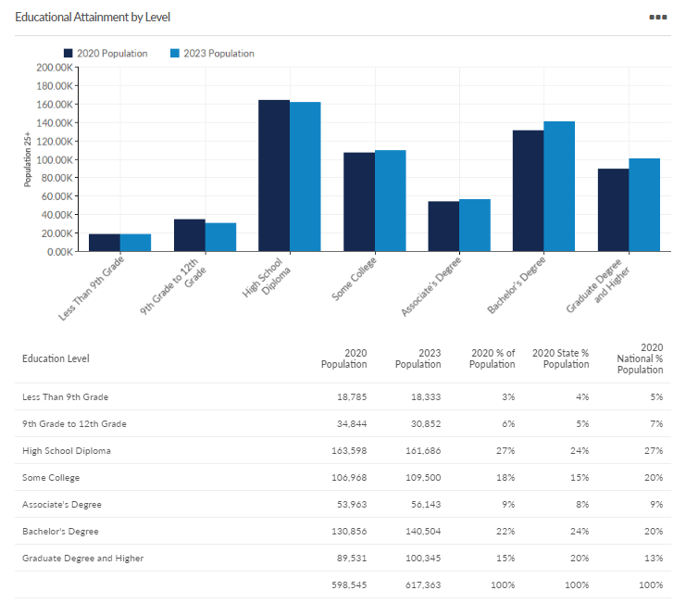
Source: Educational Attainment Snapshot, Lightcast

III. Industries, Occupations and Strategies for Workforce Development

Criteria for Priority Industries and Occupations:
State criteria for selection of priority industries and occupations:
- High Employer Demand
- High Demand and High Wage (4-5 Star Occupations)
- Talent Gaps
- Career Pathways

Additional Regional Criteria:

- Strong Employer engagement (employers willing to become actively engaged in working with workforce system stakeholders)
- Low barriers to employment (employment opportunities that do not by their nature exclude residents with barriers to employment, such as those that exclusively seek bachelor’s degrees or above)
- Alignment with high need job-seeker populations (employment opportunities that may be available to job seekers currently ready for employment or those with the ability to gain readiness with short term education, training, and support)

Priority INDUSTRIES by 2-digit NAICS code:

The priority industries that the regional planning team selected are:
- Healthcare and Social Assistance (NAICS Code 62)
- Manufacturing (NAICS Codes 31-33)
- Transportation, Warehousing and Logistics (NAICS Code 48-49)

These industries were identified as PRIORITY in our region primarily due to a high need for workers in these areas and the fact that they offer defined career pathways for residents in our region that face barriers to employment, such as the long-term unemployed, people lacking formal education credentials, criminal backgrounds, or limited English skills.
It should be noted that Information Technology, while not selected as a priority industry, is selected as an occupational cluster (below) due to the fact that jobs in this field span a variety of industries.
The rationale for selecting the healthcare and social assistance as a priority industry in our region reflects the size of this sector and large volume of jobs, as well as the constant need employers within this industry state they have for trained workers. While the entry level jobs such as Certified Nursing Assistant (CNA), Personal Care Assistant (PCA), Home Health Aid (HHA) and direct care workers often suffer from lower pay due to low public reimbursement rates, with additional education and/or training, there are opportunities to move into higher-level positions. Our region is also desperate for the qualified human services staff necessary to fight the mental health and opioid crisis, such as addiction and mental health counselors, whose impact then helps others acquire the support necessary to enter the workforce.
The largest education priority currently is for child development center teachers. Most centers now require at least 50% of their staff to have a minimum of an associate degree. However, due to public voucher reimbursement rates, the starting salaries can be low. There is also a great need for Special Education Instructors and Applied Behavioral Analysis Technicians. These programs do require an advanced degree but starting salaries are between $40,000 and $50,000 per year. There are also numerous career pathways available for education jobs but most, if not all, will require further education.
In the current job market, entry-level positions in manufacturing continue to be in demand, particularly for roles such as production workers and technicians, assemblers, machine operators, and mechanical technicians. Wages in manufacturing have increased, with starting wages ranging between $19-24, depending on the entry level skills of the position. One of the current challenges lies in the lack of awareness or misconceptions about the manufacturing industry. Manufacturing constitutes an ecosystem that offers a variety of career pathways for entry-level workers seeking advancement within the field.
To advance in a manufacturing career, many positions require additional training, often in the form of certificates or credentials, and some may even necessitate an associate degree. These educational prerequisites reflect the industry's dedication to robotic and automation innovation, which creates opportunities for developing new skill competencies and fostering professional growth. Manufacturing remains a priority sector in our region due to the promising prospects it offers for career advancement.
Similarly, the transportation, warehousing, and logistics sectors maintain a consistent demand for staff. These fields often provide above-average entry-level pay, especially for roles such as commercial drivers. Notably, these industries offer low barriers for candidates, including opportunities for individuals with criminal backgrounds, which contributes to robust employer engagement.
Regional priority Occupations or occupational groups by SOC code:
The priority occupation groups the regional planning team identified are:
- Healthcare Practitioners Occupations (SOC Code: 29-0000)
- Production Occupations (SOC Code 51-0000)
- Computer and Mathematical Occupations (SOC Code 15-0000)
- Transportation and Material Moving Occupations (SOC Code 53-0000)
- Construction Occupations Construction and Extraction Occupations (SOC Code 47-0000)

The occupations were identified based upon the State and regional criteria listed above. Healthcare practitioners form the largest employment sector in our region and CNAs, LPNs, RNs, as well as Pharmacy Technicians and Direct Care staff are in extremely high demand as evidenced by the more than 8,000 separate jobs posted online (as tabulated by Lightcast Labor Insights). Additionally, there are several high-quality training programs in our region that provide potential healthcare workers with the certification(s) required to enter or advance in this field. We have also learned from our DTA partners that many of their adult and Title 1 clients are interested in the healthcare field, so these opportunities are also a good fit for many of our region’s more vulnerable job seekers.

Production occupations have been prioritized in our region due to the significant demand resulting from the retirement of the existing manufacturing workforce. Among these roles, CNC machinists and Production Technicians remain highly sought after throughout the manufacturing industry. As manufacturers automate their production processes, skilled production technicians and machine operators are essential for machines on the production floor. Fortunately, our region benefits from several robust training programs that offer certificates in CNC machining and production technology, enabling individuals to acquire the necessary skills.
One challenge in the supply of CNC machinists is the need for training in the latest technology, as many experienced machinists may find their prior knowledge becoming outdated. However, with the support of our partners, we are actively working to retrain existing workers to become CNC machinists and increase the number of young individuals entering this field. This proactive approach ensures that our workforce remains competitive in the ever-evolving manufacturing landscape.
The region has chosen Computer and Mathematic occupations due to the anticipated continued growth of employment in this occupational group which spans across a variety of industries, including healthcare, warehousing, retail, manufacturing, etc. Jobs in this occupational group include software developers which have a high demand -- there were more than 800 positions posted in the Worcester MSA last year as tabulated by Lightcast, and this demand is anticipated to grow faster than average with strong wages (the mean advertised salary for software/web developers is more than $108,000 annually).
Transportation and Material Moving occupations were identified in our region based upon the fact that there is strong demand, fairly low employment barriers (including opportunities for people with criminal records and or low formal education), and the opportunity to earn a living wage. Among these are jobs as commercial drivers which offer in-demand employment opportunities with a strong salary. The starting salary for commercial drivers in the region is typically somewhere between $20.00 and $23.00 per hour, and there were more than 1,700 driver positions posted in Worcester County this past year as tabulated by Lightcast. This high demand has been noted by local Commercial Driver License training providers who report their students often receive a job offer before he/she has even completed the training.
Our final occupational group selected is Construction and Extraction. Jobs in this group include the so-called “hard trades” such as electrical, carpentry, plumbing, roofing, and masonry. This group of occupations requires little formal education for entry and is often more flexible when reviewing candidates with past missteps, language barriers, or other challenges job seekers face. Workers in these trades are often affiliated with organized labor unions and employer-sponsored associations which offer apprenticeship opportunities leading to strong post-secondary education and long-term formal (and portable) industry credentialing, along with the chance to earn living wages.
Non-credential Asset and Gap Analysis:
There are several existing assets in our region that we can use to meet employer demand for skilled workers. The number one complaint from businesses is that workers are lacking soft skills. The region is fortunate that many education and training programs offer classes that address aspects of workplace readiness, including the Bounce Program offered at the Workforce Central Career Centers. Bounce is a week-long training workshop that helps job seekers gain confidence, learn how to utilize goal setting techniques, and increase their employability skills. It also offers practical tools for combining seamless technical and literacy skills. Going forward, there are plans for expansion of the Bounce program to reach more job seekers. Another tool utilized within the region to help train soft skills is the Signal Success program from the Commonwealth Corporation. This comprehensive curriculum helps young people develop essential soft skills for future success. Additionally, we are looking at developing a standardized soft skills training program that could be made available to all regional partners, including high schools, post-secondary schools, and adult training programs.
The most essential assets in our region are our ESOL and ABE programs. With the influx of New Americans and workers who never finished high school, we are seeing an increased demand for these services. Adult basic education classes help workers strengthen their academic skills and/or complete their high school equivalency. Even with the most basic of entry level jobs, it is nearly impossible to earn a decent wage without a high school diploma. The ABE program is a wonderful way to get these job seekers the basic education they need to be successful. Because of the wait lists that currently exist in our region for ABE programs, the region is also seeking to expand the use of the Career Readiness Initiative/ACT Work Keys resource to local training and community partners. This web-based assessment and learning management system can provide a scalable, cost-efficient tool for multiple venues across our region.
ESOL is the most in-demand program in the region. There are extensive waiting lists at all of our career centers and also at partner agencies who offer ESOL training. A large part of increasing demand for ESOL services is due to businesses indicating that it is difficult for them to hire workers who cannot understand or speak English. The language barrier creates additional concerns with giving direction, basic communication skills, supervision, and safety. The region is continually looking for ways to increase capacity for ESOL services in Central, MA. This will allow for additional help so more job seekers enter the workplace and, in turn, increase economic development throughout our region.
Vision, Mission, Goals
The regional planning team has established the following vision statement for the region’s efforts:
The residents of Central MA have the skills needed to live prosperous, productive lives which support a strong regional economy.

Mission Statement:
Our mission as a collaboration of Central MA workforce stakeholders is to create a responsive and connected workforce system that prepares residents throughout their lives for living wage career opportunities by meeting the labor demand needs of our local businesses.
To support this mission, we as partners collectively agree to take ownership for actively engaging with our partners to integrate our services and develop programming that aligns with our region’s workforce needs.

The regional goals that the planning team has established are:

Goal 1: Align and coordinate regional Education, Workforce Development, and Economic Development systems.
- Convene Partnership leaders twice annually to review progress and regional labor market information, and to adjust programming and planning, as necessary.

- Interconnect existing workforce structures and membership between the partner systems to ensure real-time communication and programmatic alignment.
  - Workforce Development Boards, Youth Councils, and Adult/Career Center subcommittees
  - MassHire BizWorks regional team
  - Central and North Central WIOA Partner oversight groups
  - School industry advisory committees

- Collect business service performance and outcome data from all stakeholders to create a comprehensive regional “dashboard” report for public audience to highlight the value we collectively bring to businesses, including the development of qualified labor for the region’s employers.

Goal 2: Provide industry with a training system responsive to workforce needs.

- Ongoing coordination with the regional Mass BizWorks “response-team” to serve as the connection between businesses in need and system partners (see attachment 5 - Regional Demand-Driven Programming Development).

- Continuously Integrate business need feedback into regional Youth Council, Career Center, and partner program development processes

- Support the MA EOLWD Recruitment Solutions Initiative (RSI) referral process at all of the region’s MassHire Career Centers

Goal 3: Improve the foundational and work readiness/soft skills of our region’s labor force.
- Increase exposure to soft skills in high schools, colleges, training programs and career centers through the creation and expanded access to career readiness training materials.

- Increase career awareness activities in the region’s high schools.

- Build stronger foundational computer skills for residents (both youth and adults).

Goal 4: Close the skills gap for priority industries and occupations.

- Regularly review regional baseline measures for priority industries/ occupation goals and set target goals, including:
  - Decrease vacancy rate.
  - Increase the number of CTE program placements.
  - Improve the supply/demand ratio.
  - Increase the business utilization percentage rate for Mass BizWorks-affiliated partner services.
  - Improve career center/WIOA Partner performance (number of businesses served, job orders, job referrals, and hiring).

- Expand Career Technical Education (CTE and CTI), both day and evening, for priority industries and occupations.

- Increase exposure in secondary education to high priority industries.

- Expand incumbent worker career advancement and Registered Apprenticeships for priority industries.

- Increase contextualized ABE and ESOL programming that trains for high priority industries.

- Expand articulation agreements between education and training institutions for priority industries and occupations.

IV. HOW DO WE GET THERE?
The regional planning team has identified several strategies to achieve our goals. These include:
Strategy | Responsible entity
Sharing accountability through a Regional Partner Leadership Team (RPLT) | All (MassHire Boards to serve as convener)
Development of baseline measures and key metrics and a public outcomes dashboard report to measure our progress | RPLT
Creation of articulation agreements between educational and training institutions | K-12, higher-ed, other training partners
Expanding contextualized ABE and ESOL programming for priority industries/occupations | ABE and ESOL provider partners
Alignment of CTE programs with industry needs and expansion of off-hours programming at our Vocational Technical high schools and other training facilities | MassHire, K-12, higher-ed, other training partners
Creation of apprenticeships across priority industries | MassHire
Expansion of a regional MassHire BizWorks peer-to-peer team and real-time online platform to support their work | MassHire BizWorks
Utilizing and inter-weaving existing structures and frameworks to support our work | RPLT

Continuous Communication
The regional planning group will continue to meet a minimum of twice per year. This will help the blueprint team to identify changes in industry trends and be able to make changes in the region’s course direction, if needed. There will be regular communication with our core team through quarterly meetings to assess progress and needs. The region will also use the regional workforce development board meetings and the previously noted existing regional committees and workgroups (including WIOA partner groups, the Mass BizWorks regional team, and school industry advisory committees) to actively engage employers, share relevant information, and drive new programming.

Shared Measurement Systems
In order to ensure that we, as a region, are consistently making progress toward a shared vision, the region will continuously utilize updated Department of Economic Research data from the State as well as our WIOA partner sources. Some of the data will include:
- Enrollment, graduation, and employment by education/training program
- Employer vacancy rate by industry
- Supply/demand ratio
- Increase the business utilization percentage rate
- Improve career center/WIOA Partner performance (number of businesses served, job orders, job referrals, and hiring)

Mutually Reinforcing Activities
Our partners have pledged to offer significant support for accomplishing the goals of this regional blueprint. These include:
Education
- Create/expand CTE and CTI programs for priority industries/occupations (high school, afterschool & evening, college) including Pell-eligible programs.
- Create new training programs in the priority industries/occupations between now and 2027, including fast-track (boot camp) style programs and competency-based programs.
- Maintain bridge programs designed as a pathway from ESL to a career technical certificate and/or associate degree.

Workforce Development
    - Utilize demand-driven approach at region’s MassHire Career Centers – increase referrals to job openings and training in priority industries and occupations
    - Increase soft-skills training for career center customers
    - Prioritize the priority industries/occupation for WIOA Youth, YouthWorks subsidized youth employment placements, and other youth career development programs
    - Increase services to businesses in priority industries/occupations, including referrals to Workforce Training Fund and other resources

Economic Development
    - Increase the number of business referrals from ED to workforce in priority industries and occupations
    - Align business services/support data between ED and workforce systems – establish data sharing platform

Participation among invited members varied throughout the planning process.
Lightcast Central, MA-CT 2023

